FUNCTIONS:
Problem 1:
Create a function that returns the level of a customer based on credit limit.(Use the IF statement to determine the credit limit). If credit limit > 50000 then customer_level = PLATINUM. If credit limit >= 10000 AND credit limit <= 50000 then customer_level = GOLD. If credit limit credit limit < 10000 then customer_level = SILVER
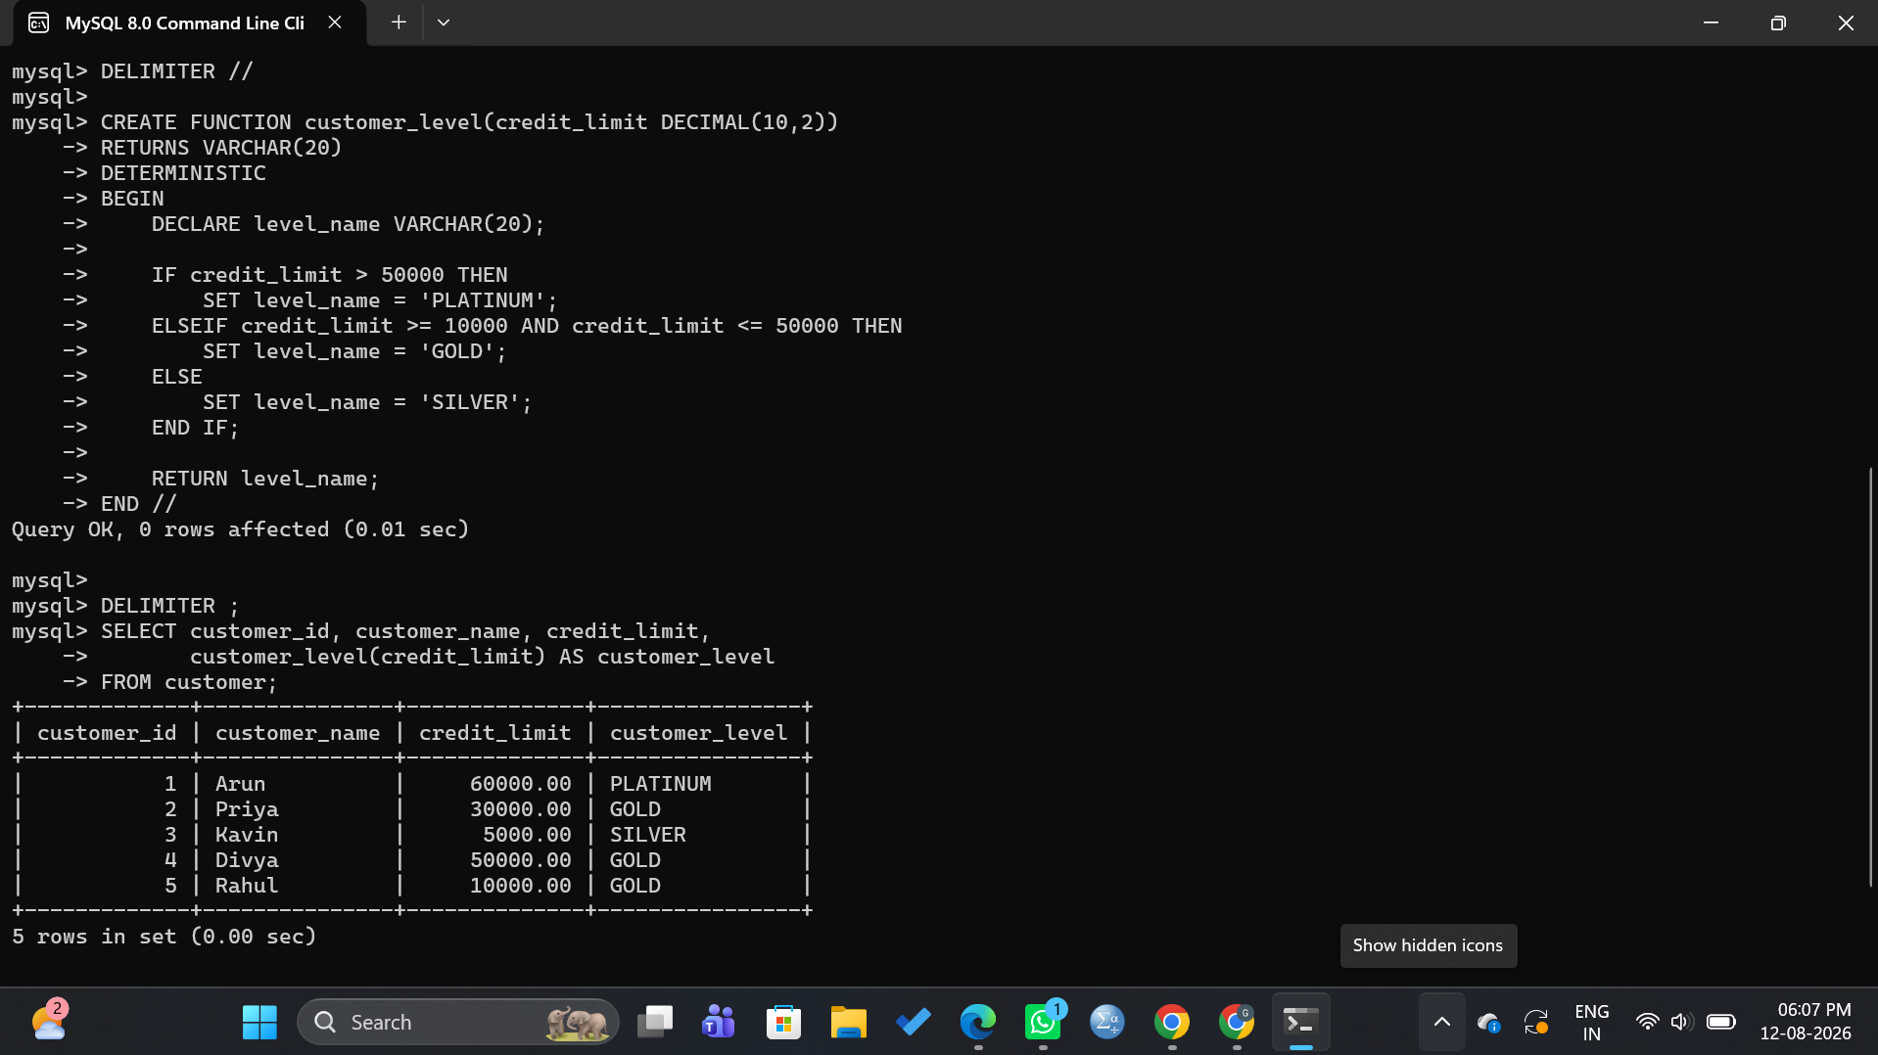
Problem 2
Write a recursive MySQL procedure compute the factorial of a number.


